Basic Concepts of LabView

LabView is a graphical programming language. It has two main windows, the block diagram and the front panel.

The block diagram, as seen in fig.1, can be quite complex. In this window is where all of the lab view code goes. It is accessed from the front panel under Window|Show Block Diagram or via the key stroke Ctrl+E.  The block diagram shows how all the controls and indicators from the front panel are wired together. | Figure 1. The LabView Block Diagram 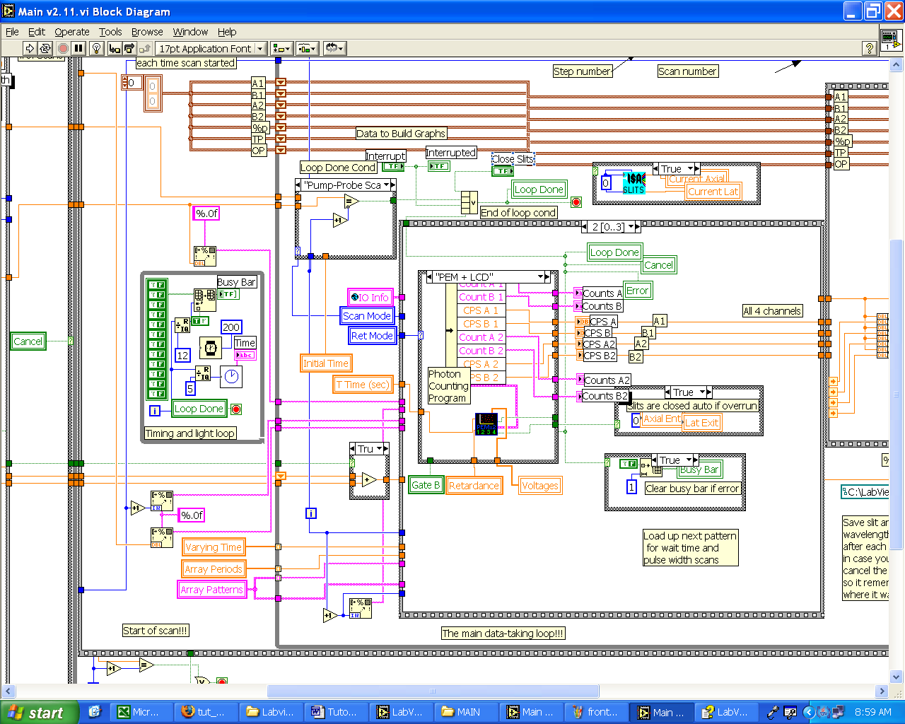
As you can see from Figure 1, LabView does not follow the same “top down” text programming structure as most other languages. It is all graphical so wires are used to connect one part to another. Because LabView does not execute from the top down, but relies on “data flow.” An item will only execute once all the necessary inputs are available.
The front panel is the where all the interface items, specifically controls and indicators, are added and organized to form the GUI.  Many of the controls are essentially “pictures” of their real-world counter parts. Thus, many of them act accordingly. For example, rotary knobs rotate and switches flip states. On the other hand, some controls do act strictly digital. | Figure 2. The LabView Front Panel  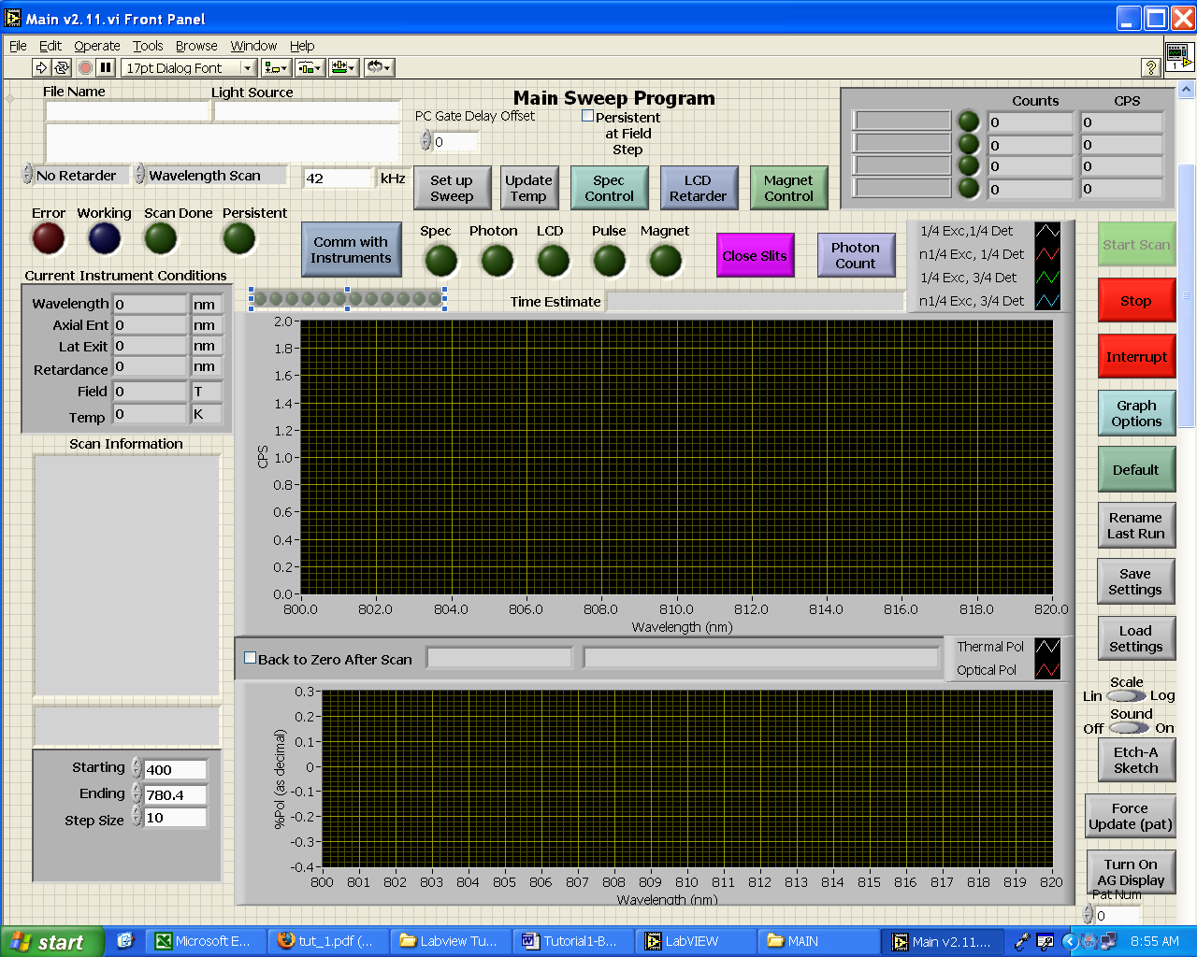
Indicators also may take on many forms. They, many times, are pictures of a real indicator and act as such – lights and panel meters. Indicators may also be designed more for charting or displaying information, such as the graphing indicator.

